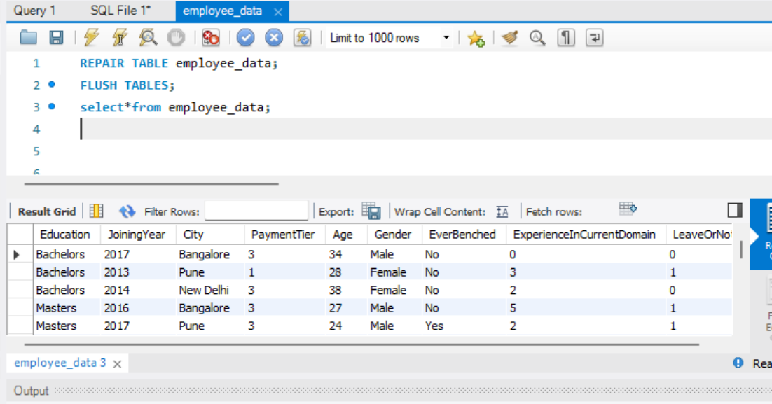import data   
select query ->

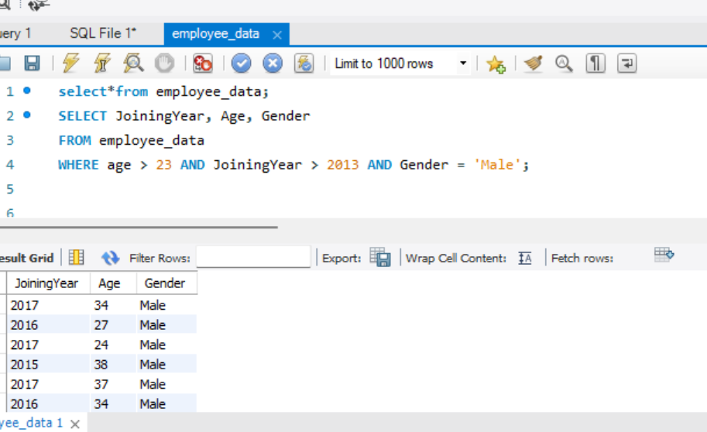  
 Where clause->

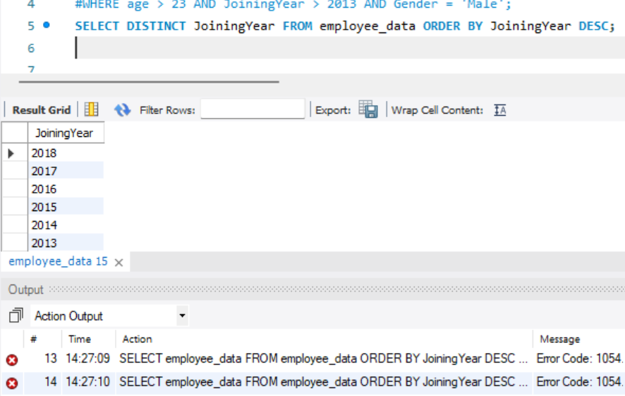

Order by->

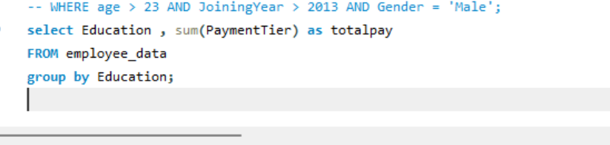  
group by->

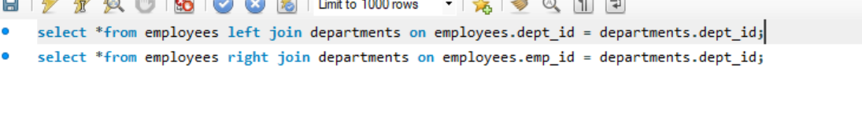  
left join ->  
right join->

Inner join->

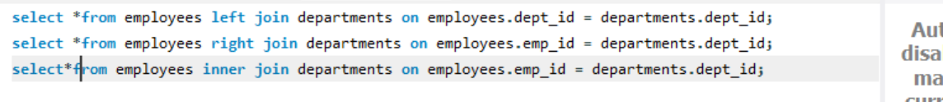

Aggregate function ->

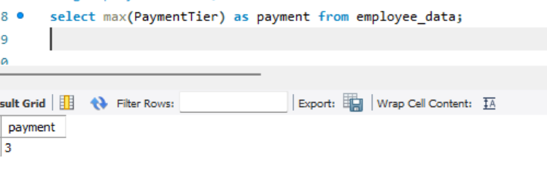

Indexing ->